Calculating Beta Using Co-variance
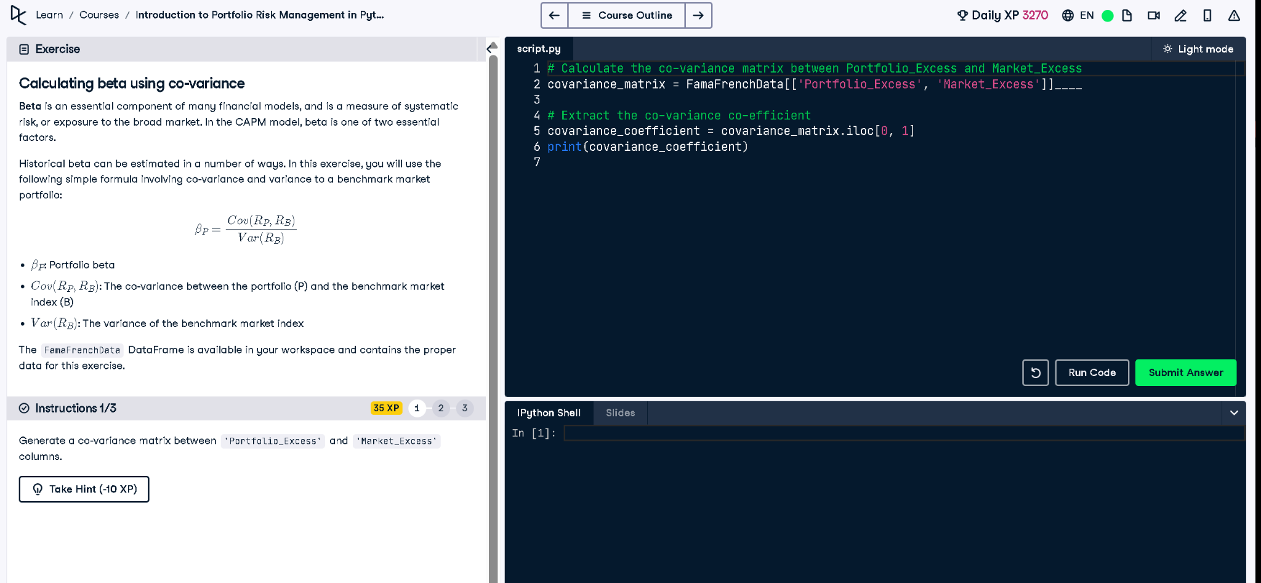

Python Code
# Calculate the co-variance matrix between Portfolio_Excess and Market_Excess
covariance_matrix = FamaFrenchData[['Portfolio_Excess', 'Market_Excess']].cov()
# Extract the co-variance co-efficient
covariance_coefficient = covariance_matrix.iloc[0, 1]
print(covariance_coefficient)

Explanation (in Simple Words)
We compute beta, a measure of systematic risk, by finding the covariance between the portfolio’s excess return and the market’s excess return. Then we extract the actual covariance value from the resulting matrix. This value will be used in the beta formula to assess market exposure.

